FACULTY EVALUATION
Programme Name: Social Entrepreneurship Development Program (SEDP)- Advance Uganda (2nd March 2026 - 6th March 2026)
Session: Operations and Efficiency
Faculty Name: Dison Bosco Okumu
No. of Respondents: 18
No. of Participants: 18
Evaluation Parameter | (%) Individual Score | (%) Programme Average
Punctuality (Commencement and Completion of Sessions) | 84 | 91
How well do you understand the core concepts presented? | 97 | 92
Rate your confidence in applying the new skills learnt | 91 | 87
Degree of Faculty preparedness for the sessions | 100 | 97
Content and methodology of the program | 97 | 95
Quality of class and group discussions | 91 | 89
The information presented in the course is relevant to my work (ministry) | 96 | 97
Average scores | 94 | 93

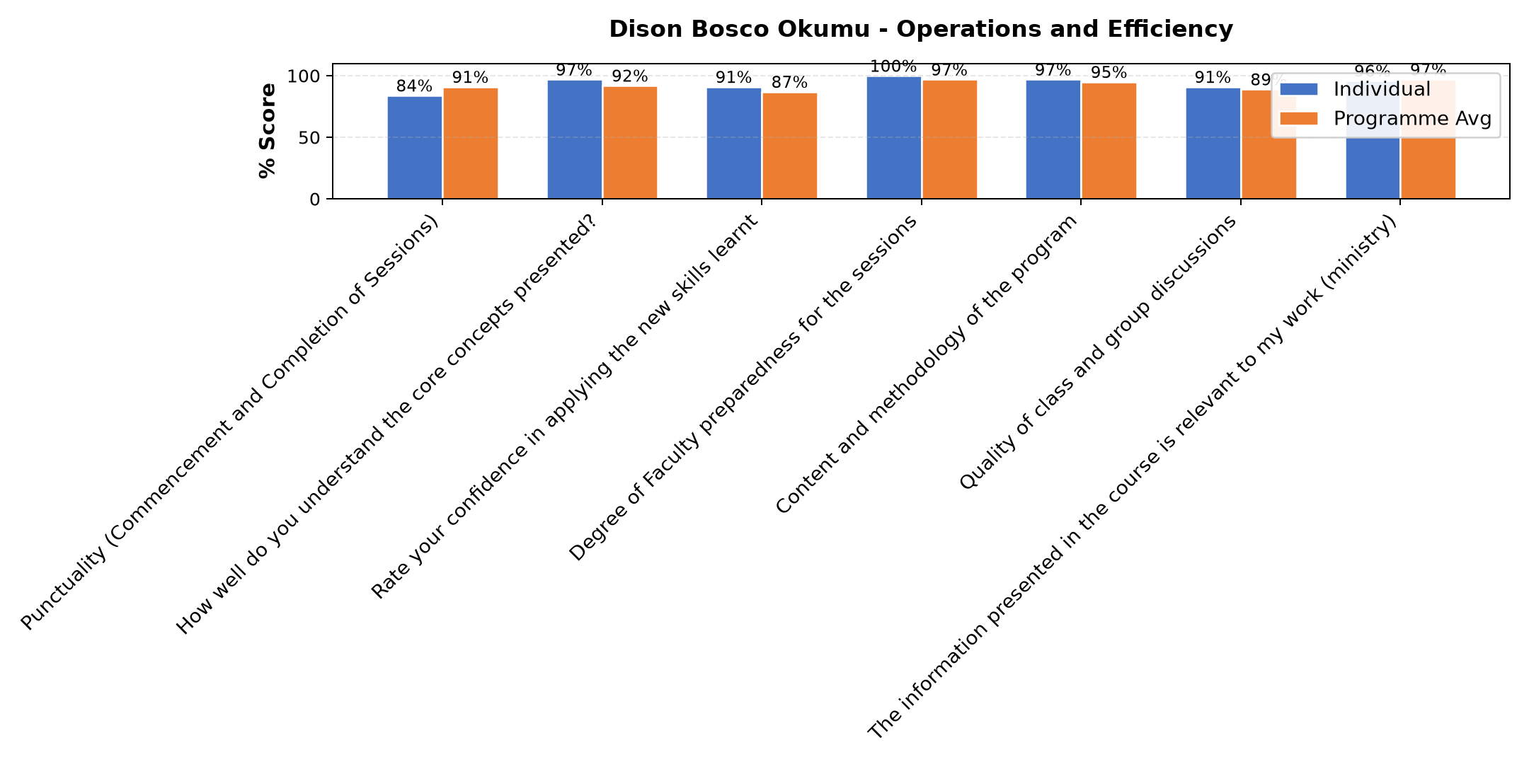

Comments & Feedback
- • Theft, inadequate resources or finance
- • Maybe lack of follow-up might prevent me from applying what I learned. Otherwise i feel strong to put into practice what I received.
- • Negative attitude
- • No any barrier at all.
- • Failing to understand people's mindset
- • Time and resources
- • There's no any barriers that can prevent me from applying what I learned because the facilitator was down on earth. And he is competent he knows what he is talking about. In fact let him always facilitate every group that comes to learn.
- • Nothing
- • So far nothing and I will try my best to implement the knowledge I have received
- • Mindset
- • Nothing
- • I feel there will be no barriers in applying what I have learnt in my Social Enterprises.
- • Not being on the ground
- • Lack of enough resources
SUBMITTED THROUGH:
SBS Evaluation Automation System

